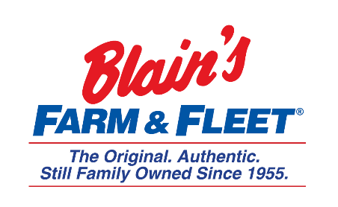

Retail Management Training Program
We are in Janesville, WI and have 42 stores located across Illinois, Iowa, Wisconsin and Michigan with our 43rd store coming this fall in Michigan.
Retail Management Training Program is a 6-9-month program. You will work with store management to learn what it takes to be a successful manager with Blain’s Farm and Fleet.
Snapshot:
- Conduct
  - Daily store walk through’s
  - Monthly safety inspections including working with Loss Prevention
  - Performance evaluations
  - Schedule associates in assigned departments
- Oversee store advertising on a local level to ensure advertising quality and store inventory/supply
- Fulfill corporate requests to ensure customer satisfaction and company goals are met
- Assist with store human resources and store operations processes
  - Interviews
  - Paid time off requests
  - On-hand negative accounts
  - Pre-prints
- Assist in maintaining all store building/facilities and grounds
- Willing and able to relocate to 7 of our 42 stores once program is completed

More about the company:
Owner and CEO Jane Blain Gilbertson’s promise is to uphold the founding philosophy of treating all associate like family and all customers like our favorite neighbors while supporting our communities. Jane’s commitment is demonstrated by making Forbes magazine’s 2019 list of America’s Best Mid-Size Employer 2 years in a row. Come see what our family owned company is all about!

