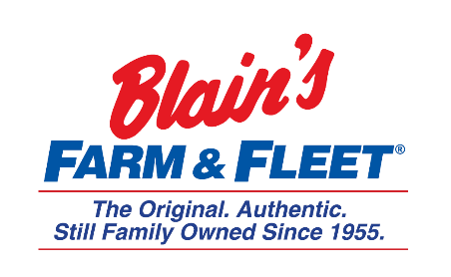

Interested in becoming a Fleeter this summer?
Merchant Internship
Blain Supply/Blain’s Farm & Fleet has an opportunity to enhance your education with real work experience in our 10-week Merchant Internship!
We are in Janesville, WI and have 42 stores located across Illinois, Iowa, Wisconsin and Michigan with our 43rd store coming this fall in Michigan.
As a Merchant Intern, you will learn the fundamentals of curating an assortment of products & driving sales.
Internship Snapshot:
- Work directly with Senior Merchandiser/Mentor
  - Item productivity analysis by using sales reports and other tools
- Coordinating efforts with divisional teams
  - Plan-o-grams
  - Merchandising standards
  - Calendars
- Shadow merchandisers during store visits to ensure merchandising standards are being followed
- Get in on the action
  - Vendor meetings
  - Selection of merchandise
  - Forecasting & working with Buyer Analyst
  - Retail advertisement
- Conclude internship with a research project & present to key leaders

More about the company:
Owner and CEO Jane Blain Gilbertson’s promise is to uphold the founding philosophy of treating all associate like family and all customers like our favorite neighbors while supporting our communities. Jane’s commitment is demonstrated by making Forbes magazine’s 2019 list of America’s Best Mid-Size Employer 2 years in a row. Come see what our family owned company is all about!

