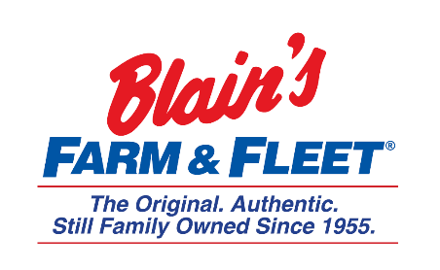

Interested in becoming a Fleeter this summer?
Marketing Internship
Blain Supply/Blain’s Farm & Fleet has an opportunity to enhance your education with real work experience in our 10-week Marketing Internship!
We are in Janesville, WI and have 42 stores located across Illinois, Iowa, Wisconsin and Michigan with our 43rd store coming this fall in Michigan.
As the Marketing intern you will work directly with our Creative Services Director & PR/Events Coordinator to learn the day to day functions of a Marketing Department.
Internship Snapshot:
- Design, implement & monitor
  - Signage
  - Circulars
  - Brochures
  - Marketing material as needed
- Coordinates the preparations of project content to ensure completion on time
- Event Planning
  - Coordination & communications
  - Arrange and coordinate appearances
  - Promote goodwill of the company and product sales
  - Attend events when needed
- Varying projects as needed

More about the company:
Owner and CEO Jane Blain Gilbertson’s promise is to uphold the founding philosophy of treating all associate like family and all customers like our favorite neighbors while supporting our communities. Jane’s commitment is demonstrated by making Forbes magazine’s 2019 list of America’s Best Mid-Size Employer 2 years in a row. Come see what our family owned company is all about!

