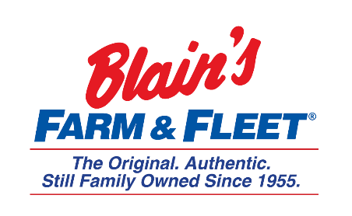

Interested in becoming a Fleeter this summer?
IT Internship
Blain Supply/Blain’s Farm & Fleet has an opportunity to enhance your education with real work experience in our 10-week IT Internship!
We are in Janesville, WI and have 42 stores located across Illinois, Iowa, Wisconsin and Michigan with our 43rd store coming this fall in Michigan.
As an IT Intern you will be part of the help desk team providing IT support to the organization.
Internship Snapshot:
- Monitor corporate help desk request & determine appropriate responses
- Establish and track calls through help desk software
- Perform tasks including
  - Support end-users remotely or in person
  - Desktop system OS & application setup
  - Non-warranty equipment repairs
  - Asset tracking for computer equipment
  - Setup, diagnostic, and simple repair of personal computer & printer hardware
- Troubleshoot printing issues
- Provide basic training:
  - Desktop
  - Notebook
  - Handheld computers
  - Mobile devices

More about the company:
Owner and CEO Jane Blain Gilbertson’s promise is to uphold the founding philosophy of treating all associate like family and all customers like our favorite neighbors while supporting our communities. Jane’s commitment is demonstrated by making Forbes magazine’s 2019 list of America’s Best Mid-Size Employer 2 years in a row. Come see what our family owned company is all about!

