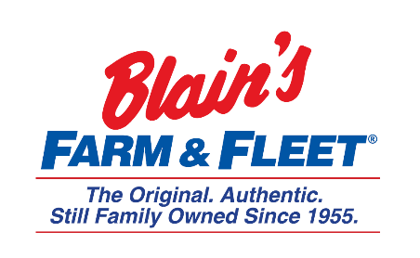
Interested in becoming a Fleeter this summer?
Human Resources Internship
Blain Supply/Blain’s Farm & Fleet has an opportunity to enhance your education with real work experience in our 10-week Human Resources Internship!
We are in Janesville, WI and have 42 stores located across Illinois, Iowa, Wisconsin and Michigan with our 43rd store coming this fall in Michigan.
As a Human Resources Intern you will get exposure to recruiting and training and how they work within the corporation.
Internship Snapshot:
- Recruiting
  - Schedule phone interviews & screen applicants
  - Learn applicant tracking system
  - Onboarding procedures
  - Support recruiting team with new store opening
  - Projects as needed
- Training
  - Employee engagement survey

More about the company:
Owner and CEO Jane Blain Gilbertson’s promise is to uphold the founding philosophy of treating all associate like family and all customers like our favorite neighbors while supporting our communities. Jane’s commitment is demonstrated by making Forbes magazine’s 2019 list of America’s Best Mid-Size Employer 2 years in a row. Come see what our family owned company is all about!

