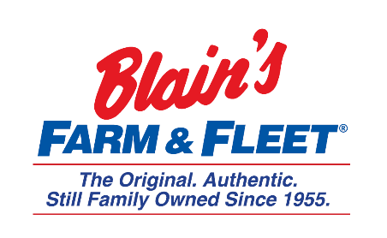

Interested in becoming a Fleeter this summer?
Finance Internship
Blain Supply/Blain’s Farm & Fleet has an opportunity to enhance your education with real work experience in our 10-week Finance Internship!
We are in Janesville, WI and have 42 stores located across Illinois, Iowa, Wisconsin and Michigan with our 43rd store coming this fall in Michigan.
As a Finance Intern you will be exposed to all areas of finance.
Internship Snapshot:
- Enter vendor contracts & design a contract management process
- Build a vendor spend cube
- Create
  - Expense templates
  - Work with senior leaders to develop expense budgets
- Assist Accounts Payable
- Shadow the Finance/Accounting leaders for day-to-day experience

More about the company:
Owner and CEO Jane Blain Gilbertson’s promise is to uphold the founding philosophy of treating all associate like family and all customers like our favorite neighbors while supporting our communities. Jane’s commitment is demonstrated by making Forbes magazine’s 2019 list of America’s Best Mid-Size Employer 2 years in a row. Come see what our family owned company is all about!

