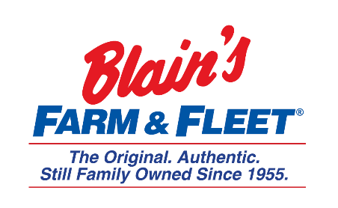

Interested in becoming a Fleeter this summer?
Construction Internship
Blain Supply/Blain’s Farm & Fleet has an opportunity to enhance your education with real work experience in our 10-week Construction Internship!
We are in Janesville, WI and have 42 stores located across Illinois, Iowa, Wisconsin and Michigan with our 43rd store coming this fall in Michigan.
As part of the Construction Internship you will assist the project management team in management and initiation of projects.
Internship Snapshot:
- Coordination of construction projects to ensure
  - Compliance with contract terms
  - Schedule
  - Quality & safety standards
- Create construction documents including
  - Material take-offs from project plans
  - Varying reports
  - Project tracking sheets
- Assist design and facilities department
- Provide inspections of project work & complete punch list
- Communication with key stakeholders on a regular basis

More about the company:
Owner and CEO Jane Blain Gilbertson’s promise is to uphold the founding philosophy of treating all associate like family and all customers like our favorite neighbors while supporting our communities. Jane’s commitment is demonstrated by making Forbes magazine’s 2019 list of America’s Best Mid-Size Employer 2 years in a row. Come see what our family owned company is all about!

